Design for Visual Systems – Logbook

# Lab 1 – Introduction to MATLAB

## Installing MATLAB

Installation complete

## Learning MATLAB Basics

Watched tutorial video

## Loading the test image

Clown loaded

## Greyscale value

Value at (20, 319) = 43

## Display image

Image displayed

## Task 1 – Image Rotation

Script created ‘Rotate.m’

Image rotated successfully

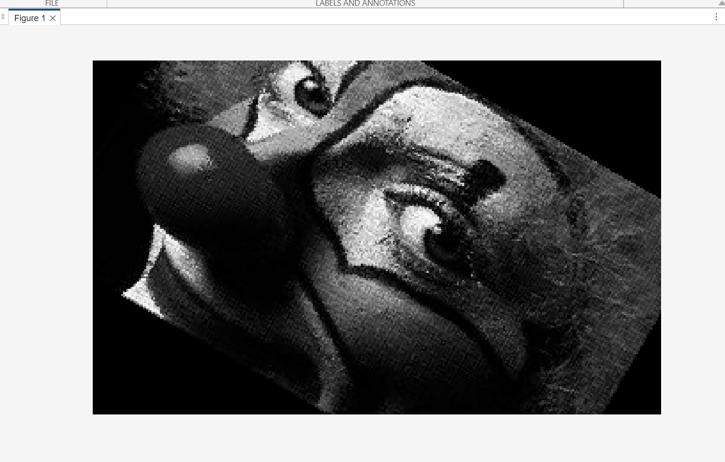

## Task 2 – Image Shearing

Script created ‘Shear.m’

Image sheared successfully

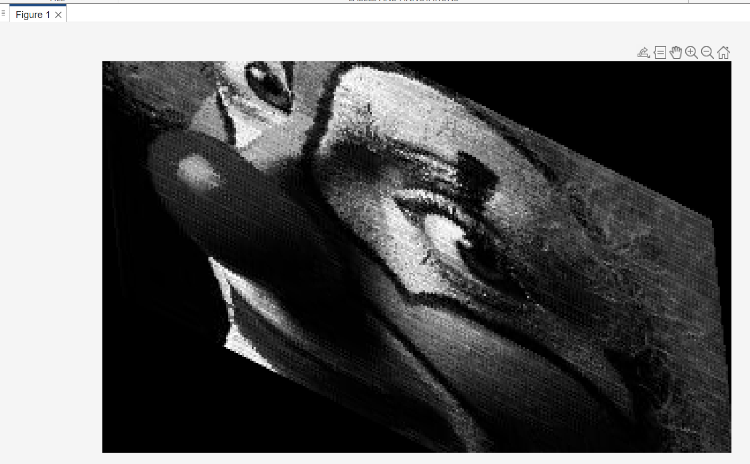

# Lab 2 – Seeing Colours and Shapes

## Task 1 – Find your blind spot

My eye has a blind spot. My brain can interpolate missing information where the blind spot is located (e.g. colour, patterns).

## Task 2 – Ishihara Colour Test

I can correctly identify all the numbers in the images.

## Task 3 – Reverse colour

After staring at an image of the American flag with ‘reversed’ colours (black, green, yellow), and then suddenly switching my gaze to a blank white sheet of paper, I see the correct colours of the American flag (white, blue, red).

The image I see is known as a ‘negative afterimage’, caused my photoreceptor fatigue. The cones in my retina are responding to the colours in the original image, firing continuously. After a while, they become less sensitive (fatigued). The cones for the opposite colours remain fresh and responsive. When looking at the white sheet of paper (white light contains all wavelengths), my brain is subtracting the fatigues response, showing the ‘opposite’ of the original colour.

## Task 4 – Troxler’s Fading

I am staring at the centre of an image containing a series of purple dots arranged on a circular path. In a series sequence, the circular dots disappear temporarily (one by one). After a while, all the dots seem to fade away, my brain then sees a negative colour of the disappearing dot (in green).

Troxler’s fading is a perceptual phenomenon where steady, unchanging stimuli in peripheral vision fade from awareness when you fixate on a central point. It happens because:

* Neurons in the visual system adapt to constant, unvarying input and stop responding strongly.
* Peripheral vision has large receptive fields, so tiny involuntary eye movements don’t refresh the image enough to keep it visible.
* The brain effectively “fills in” the missing area with surrounding colour or texture.

As a result, stationary shapes, colours, or patterns away from your fixation point slowly vanish, even though they’re still physically present.

## Task 5 – Brain sees what it expects

The two tables, at first glance, appear to be different in size. However, after measuring them using a ruler, they are exactly the same dimensions.

This is due to ‘perspective cues’—my brain is interpreting these 2D drawings as 3D objects, i.e. my brain is overriding the actual 2D geometry.

The colour of square A and B is indeed the same RGB value, however, my brain believes they are different given the contextual cue of the shadow cast by the cylinder.

## Task 6 – Grid Illusion

When staring at the grid, my brain sees appearing and disappearing discs at the intersections of the white/grey bars.

This is due to a neural process called ‘lateral inhibition’. From Wikipedia: “The intensity at a point in the visual system is not simply the result of a single receptor, but the result of a group of receptors which respond to the presentation of stimuli in what is called a receptive field”.

## Task 7 – Café Wall Illusion

In the second example the ‘café wall illusion’, by brain sees wavy lines between the white and black squares, although they are in fact parallel lines. When the contract is changed (to pink and blue square), my brain indeed sees parallel lines.

This happens because my brain interprets the size the white squares as being greater than the black squares.

## Task 8 – The Silhouette Illusion

My brain only sees the dancer spinning clockwise. Apparently, some people see the dancer spinning in the other direction after some time.

## Task 9 – The Incomplete Triangles

By brain sees 2 triangles, one that is full white, on top of one with a black outline, although technically there are zero complete triangles.

# Part 2

## Task 10

Image information displayed

Image displayed

Image converted to greyscale

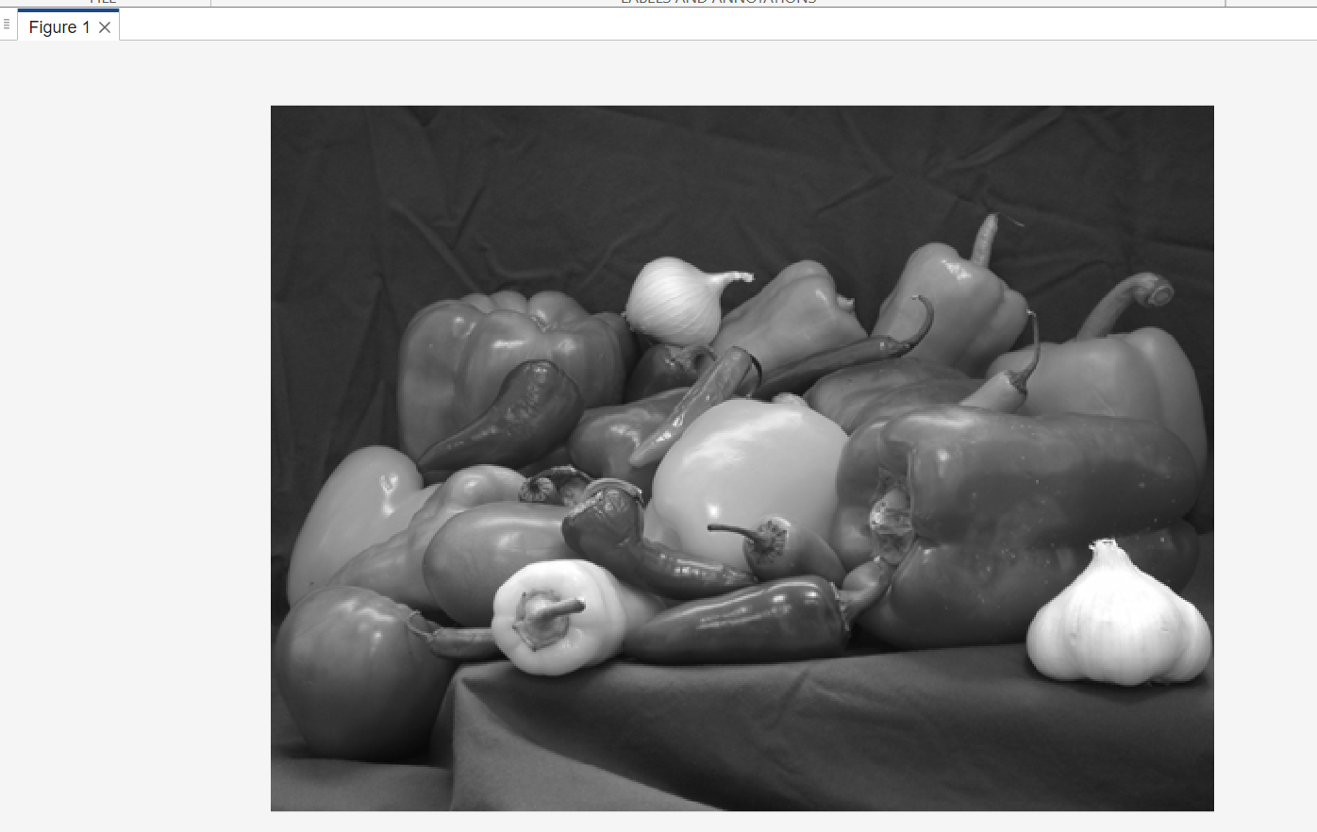

Images displayed side by side

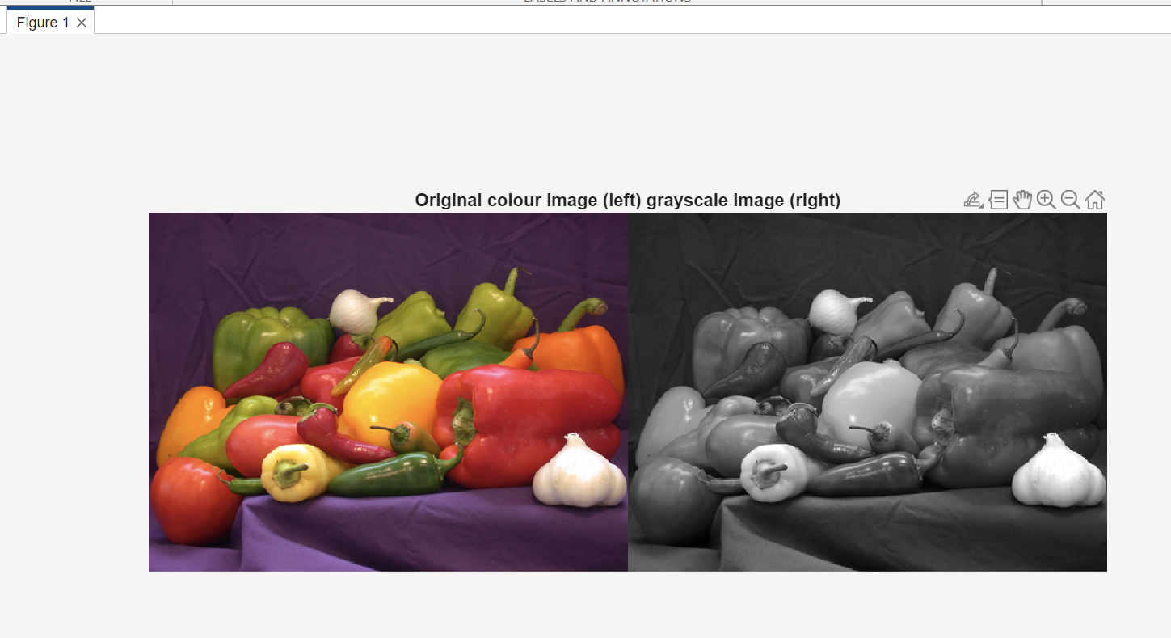

## Task 11 – Splitting and image into separate channels

Image split successfully

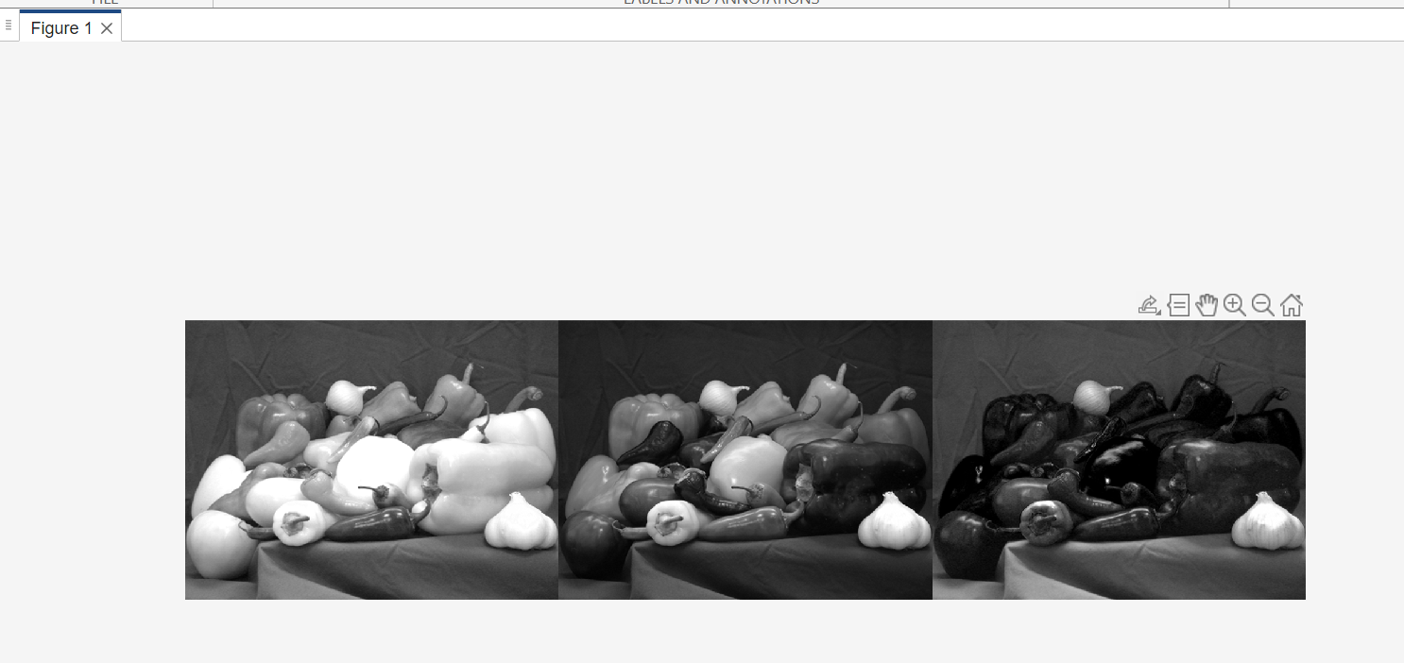

## Task 12 - Map RGB image to HSV space and into separate channels

Image successfully split into HSV space separate channels.

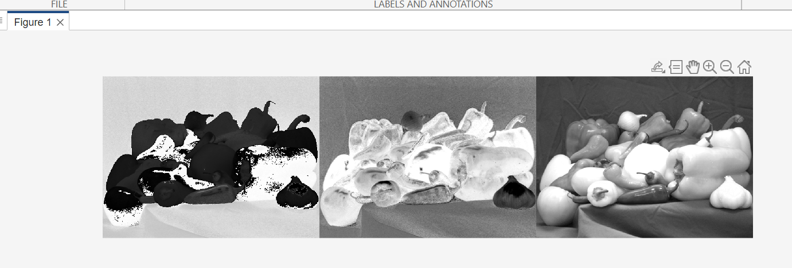

## Task 13 – Map RGB image to XYZ space

Image successfully split into XYZ space separate channels.

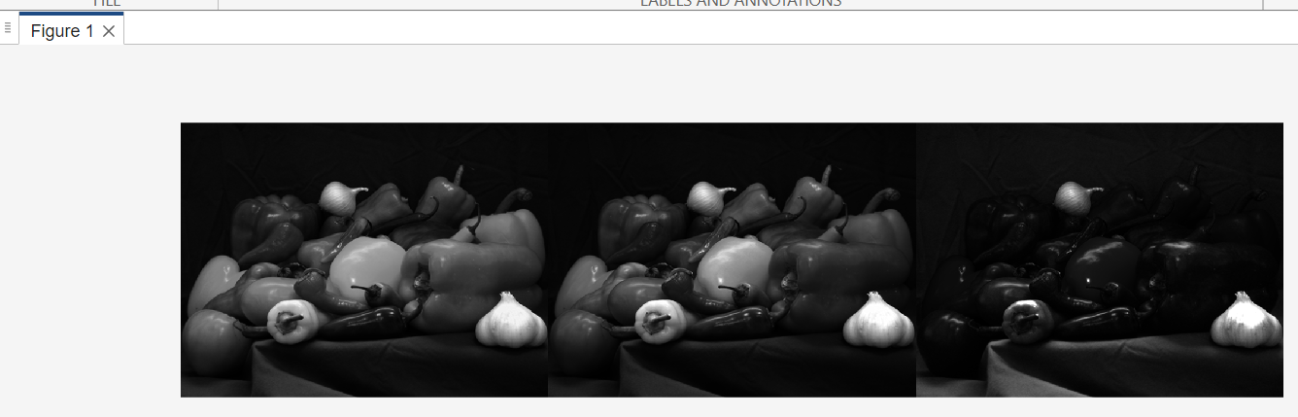

# Lab 3 – Intensity transforms & Spatial filters

## Task 1 – Contrast enhancement with function imadjust

Image imported, information checked.

Intensity of pixel (3,10) = 28

Display only top half of image:

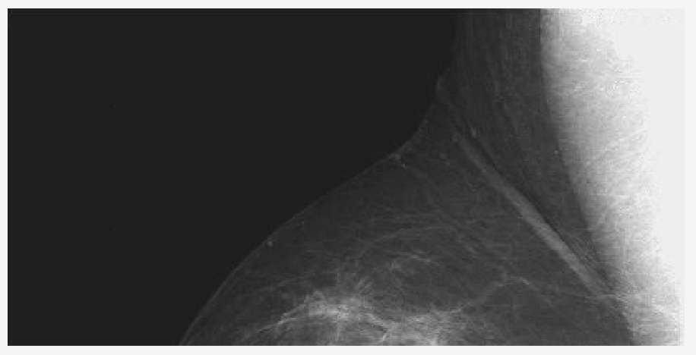

Maximum intensity value (of original image) = 21

Minimum intensity value (of original image) = 255

Display only right side of image:

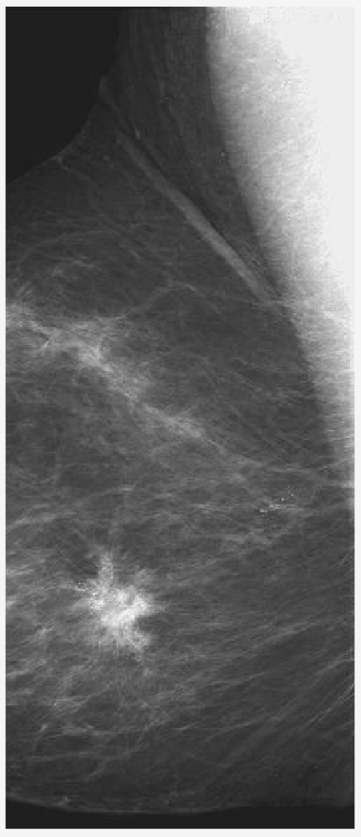

Negative Image

Display negative image and display both side by side:

{original, imadjust}

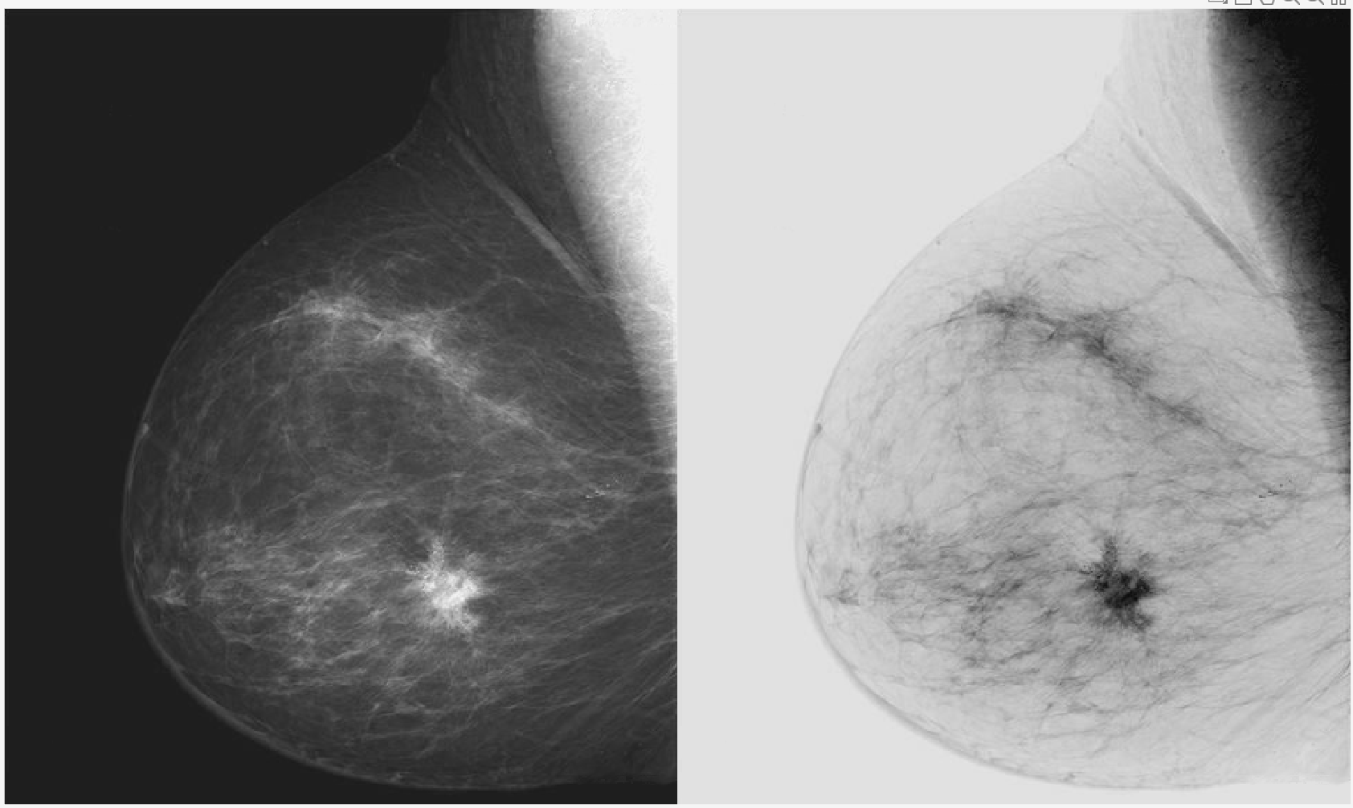

Gamma Correction

After applying ‘imadjust’ for gamma correction:

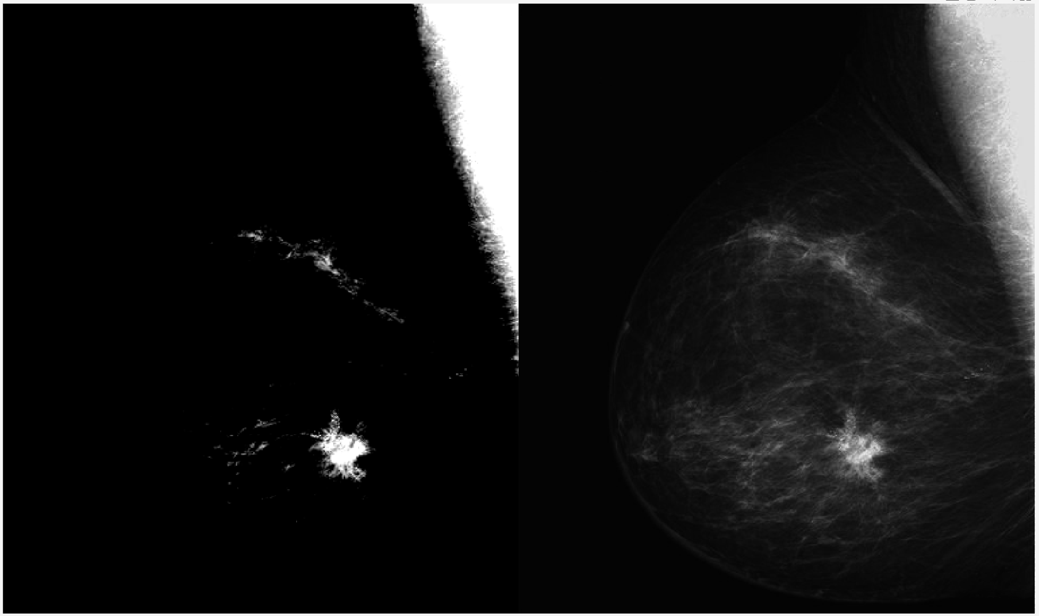

## Task 2 – Contrast-stretching transformation

Contrast stretching transformation applied successfully:

{original, contrast stretched}

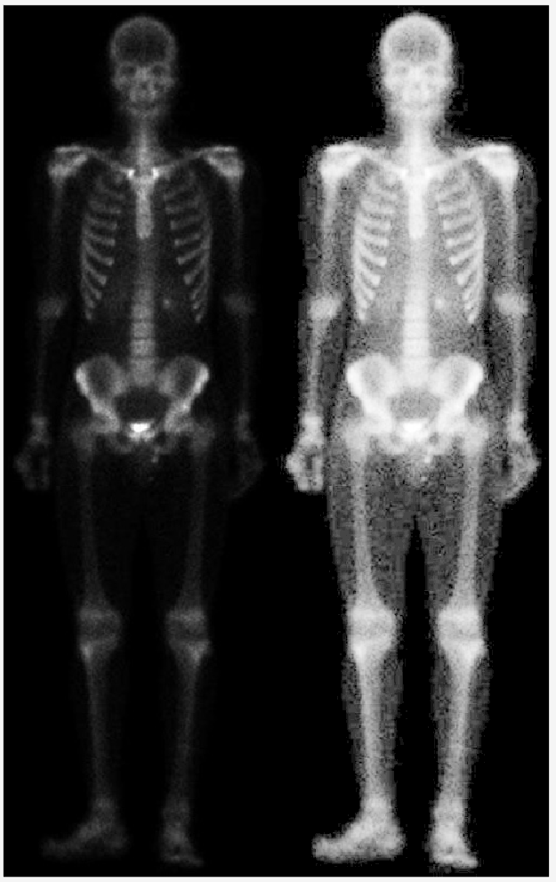

The contrast stretched image makes it easier to see the contours of the body being imaged.

## Task 3 – Contrast Enhancement using Histogram

Image histogram created successfully:

{original, histogram}

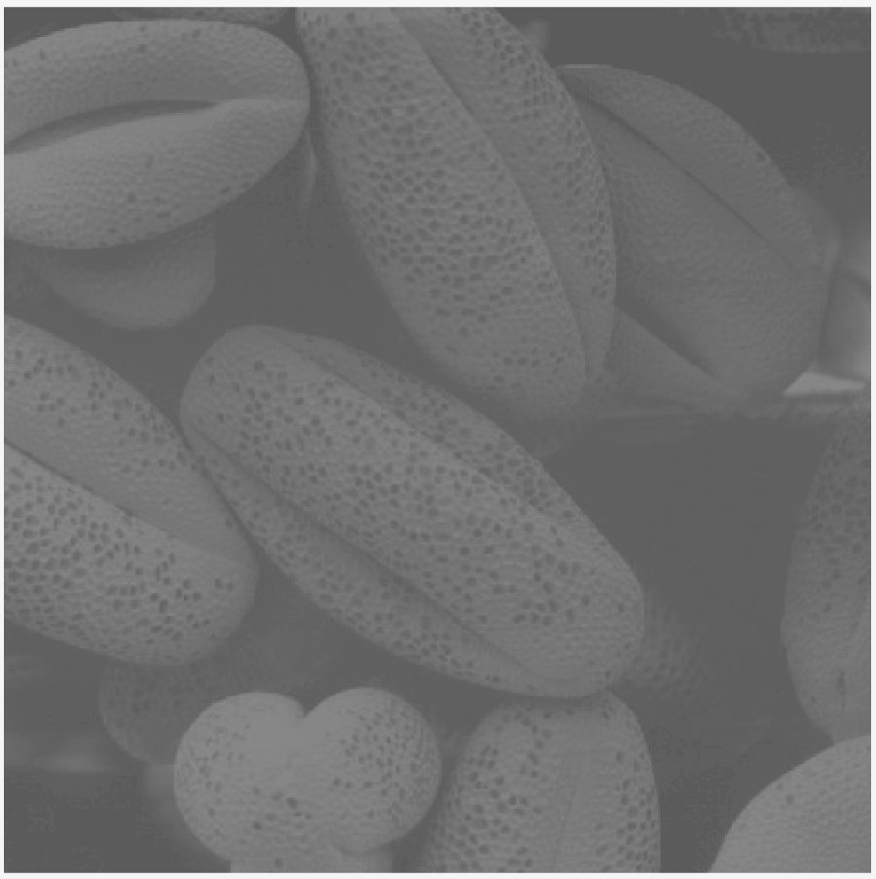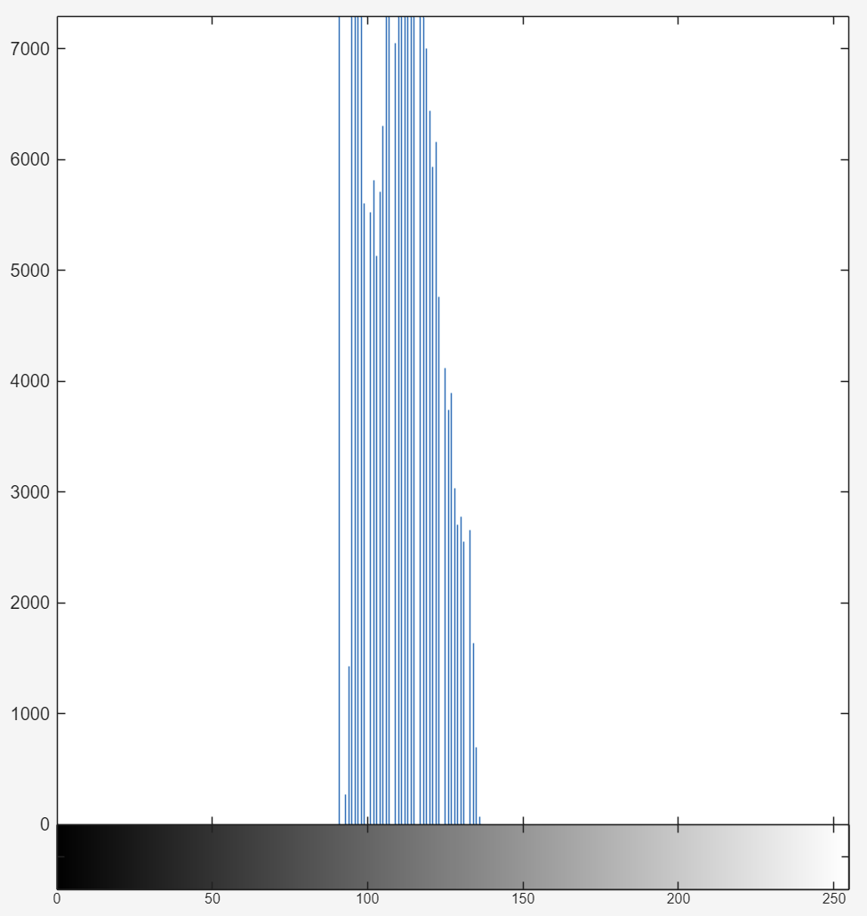

Image adjusted using *imadjust*:

{original, imadjust}

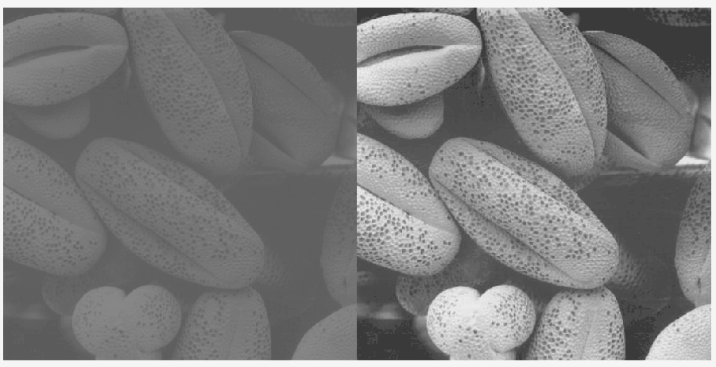

{histogram of imadjust}

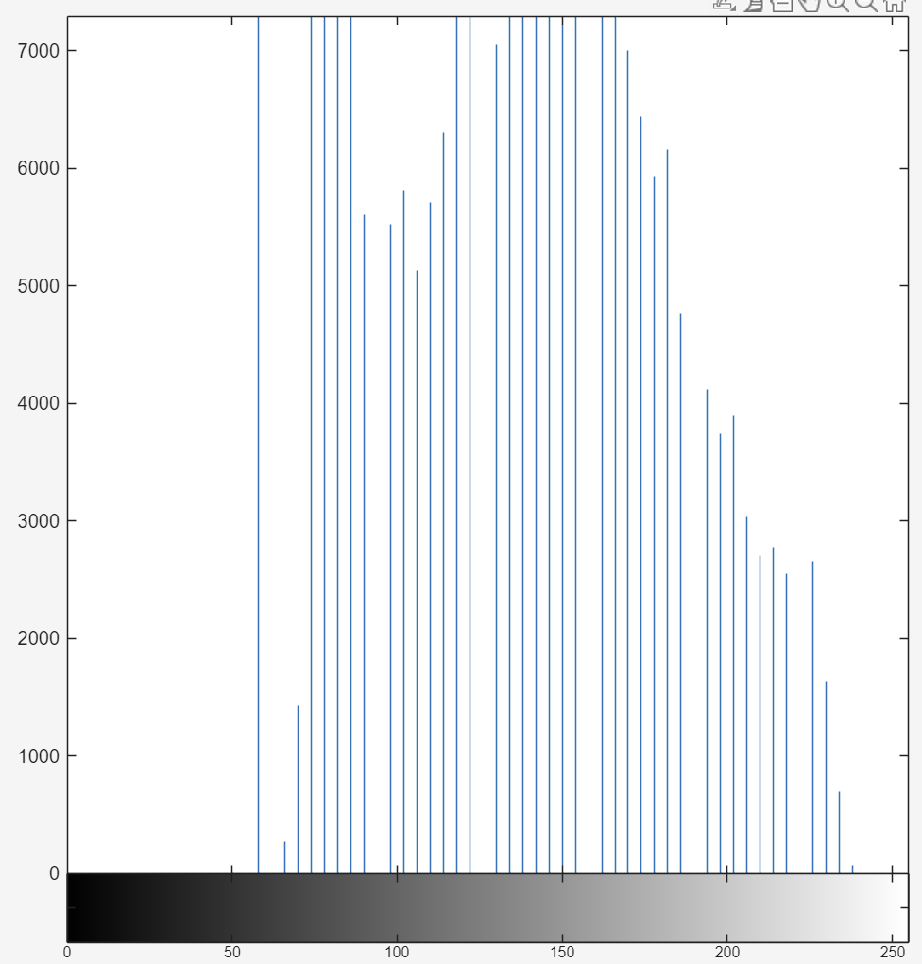

The histogram is more evenly distributed across the spectrum compared to previously.

Histogram PDF and CDF

{histogram PDF, histogram CDF}

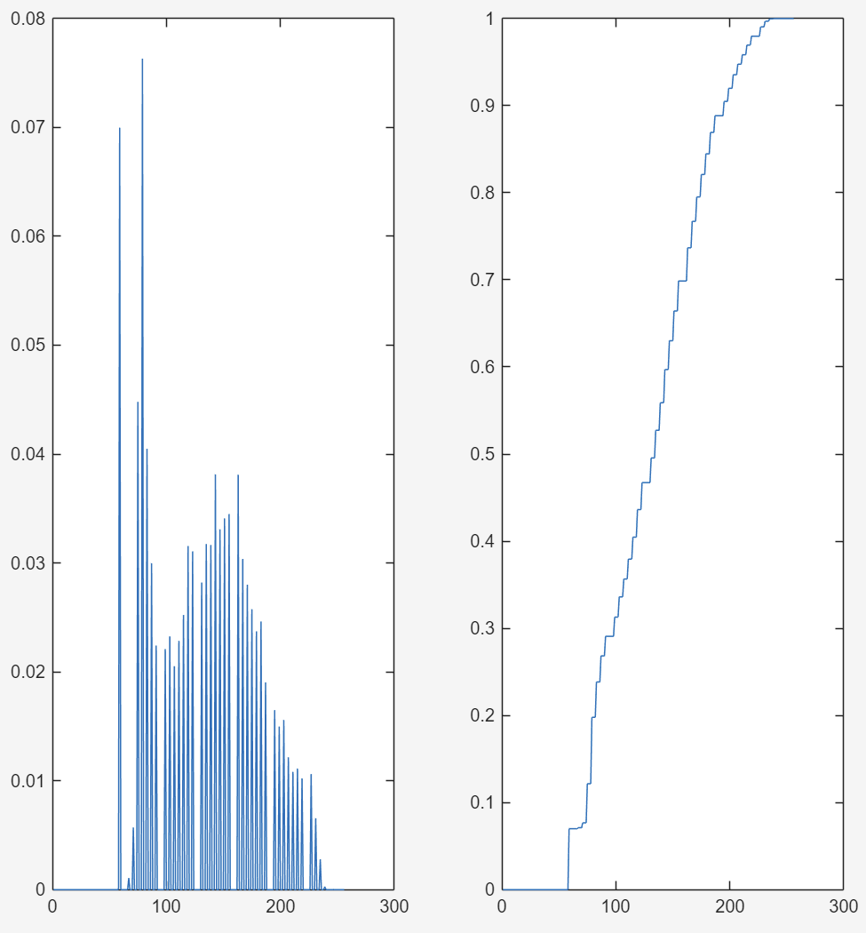

Histogram equalization

{equalised histogram}

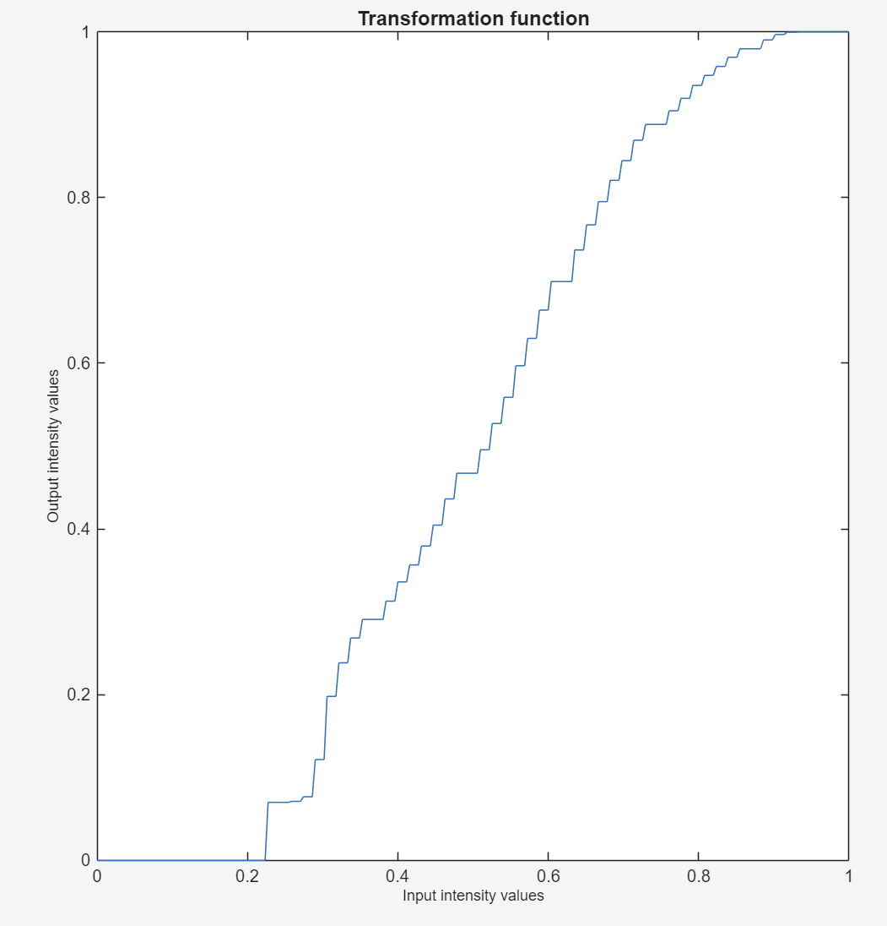

Plots of all three images and their histograms:

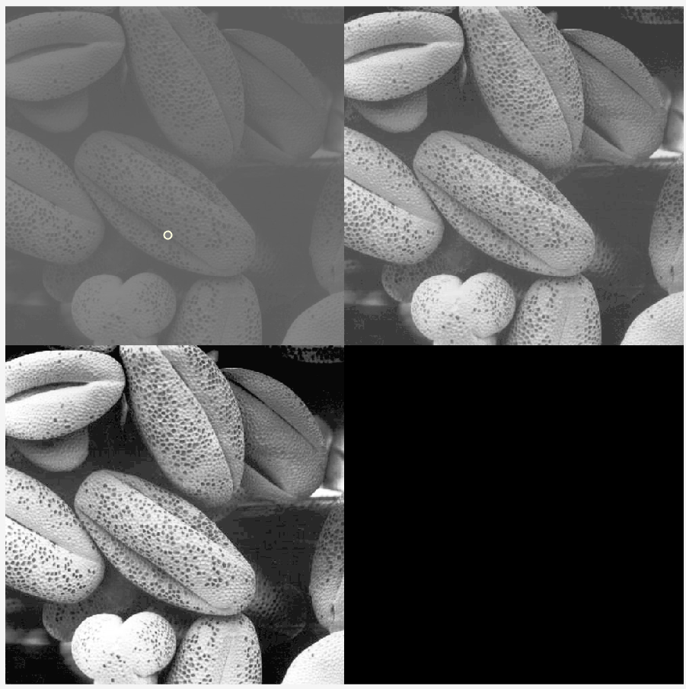

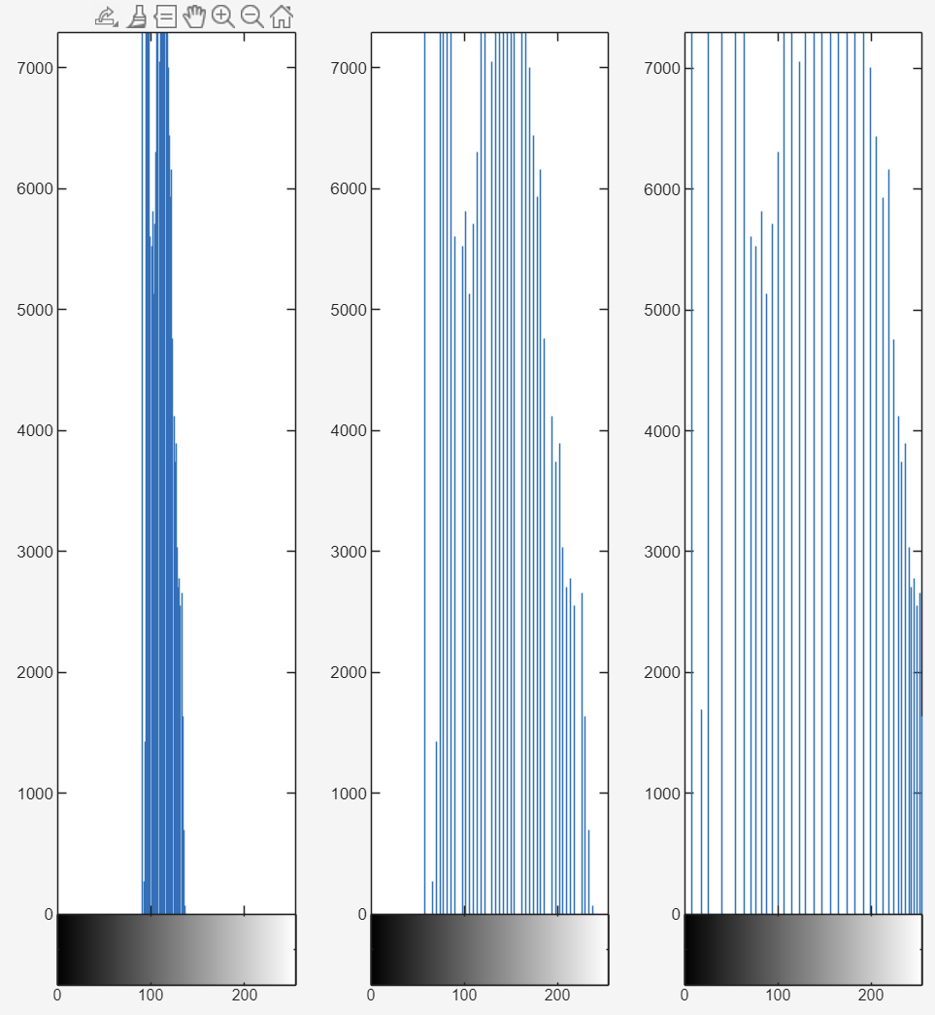

## Task 4 – Noise reduction with lowpass filter

Noise reduction with lowpass filter applied successfully.

{original, imfilter (average), imfilter (gaussian)}

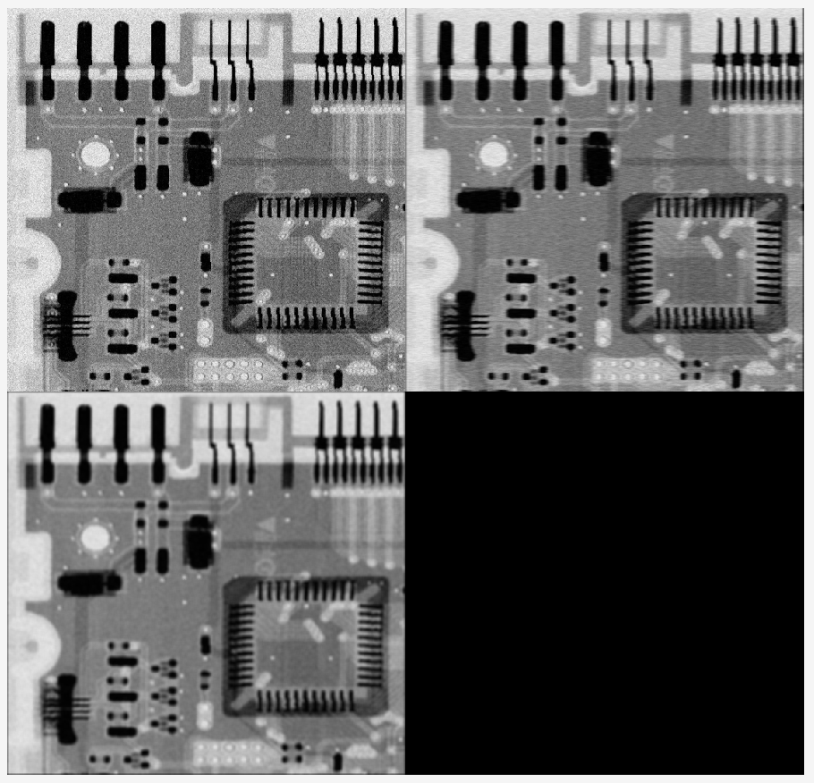

{histogram}

The average filter is blurry, gaussian is a slight improvement. Changing the kernel and sigma size has a big impact on output.

## Task 5 – Median Filtering

Result of median filtering:

{original, median filter}

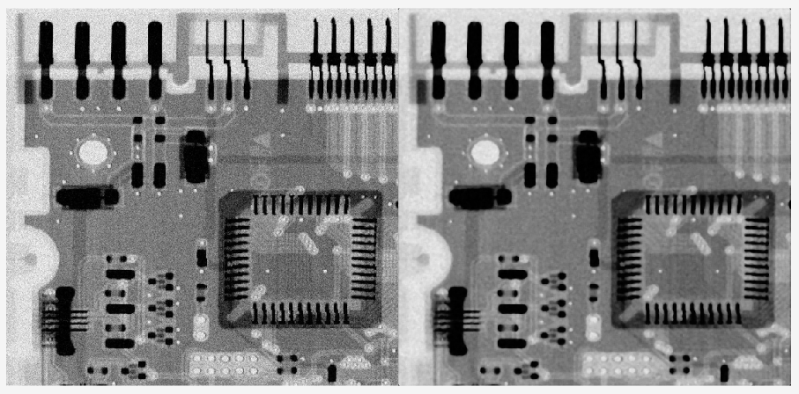

The resulting image has significantly less noise than the original, but is less ‘sharp’.

## Task 6 – Sharpening the image with Laplacian, Sobel and Unsharp filters

Image of moon sharpened successfully:

{original, sharpened}

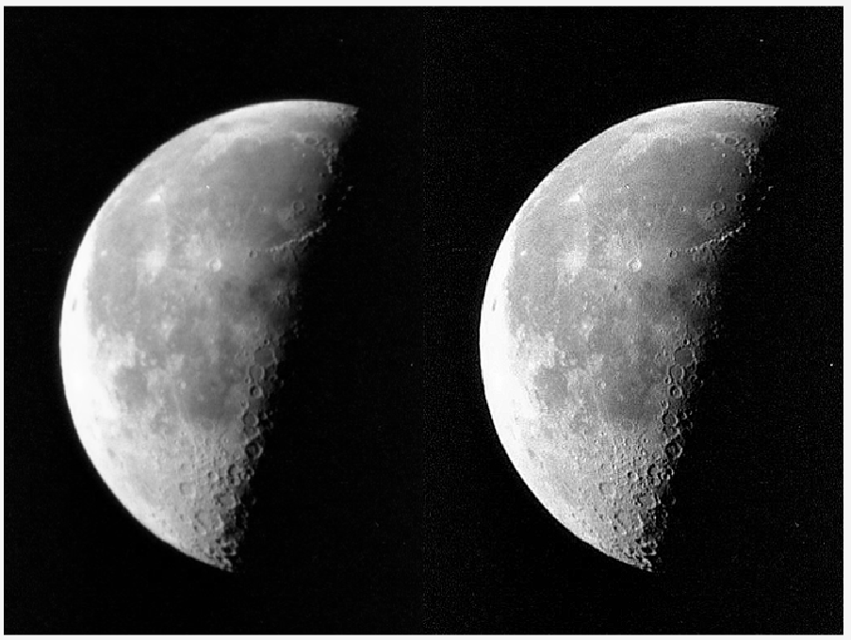

The result is a significant improvement over the original.

Applied Laplacian filter to enhance edges of moon:

{original, Laplacian}

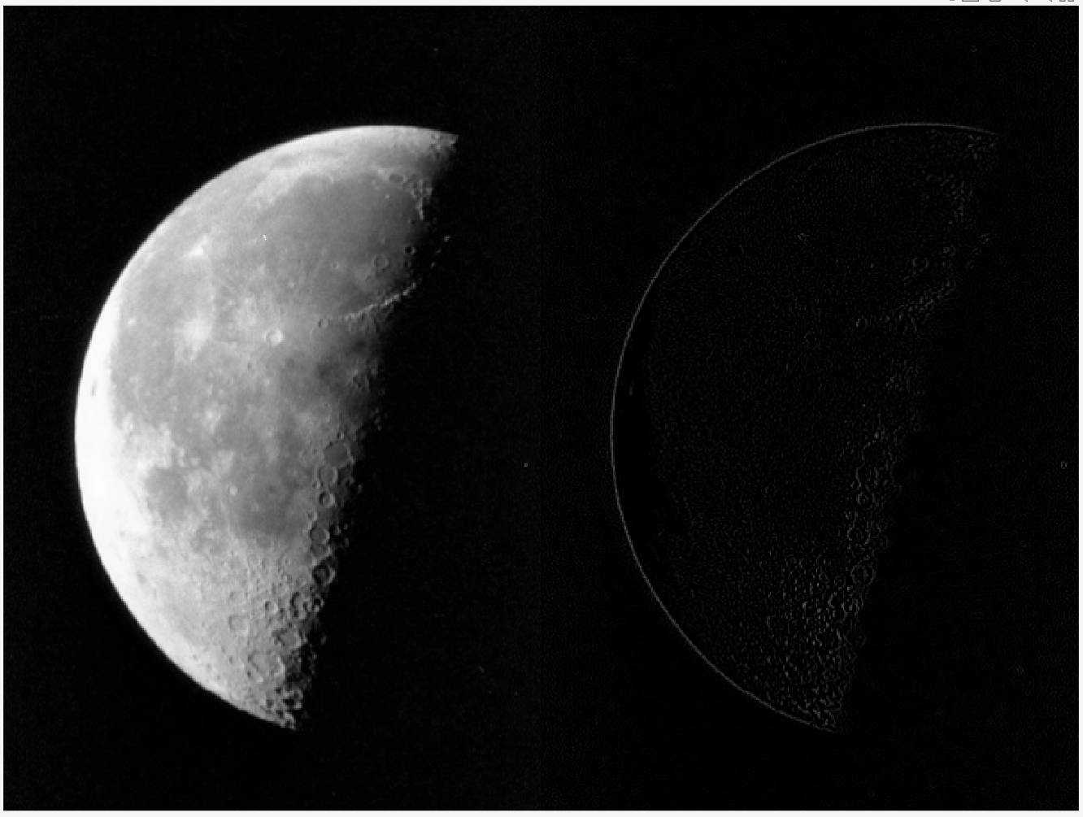

## Task 7 – Test yourself Challenges

Contrast of image of tree and lake improved significantly using ‘*imadjust’* function.

{original, imadjust version}

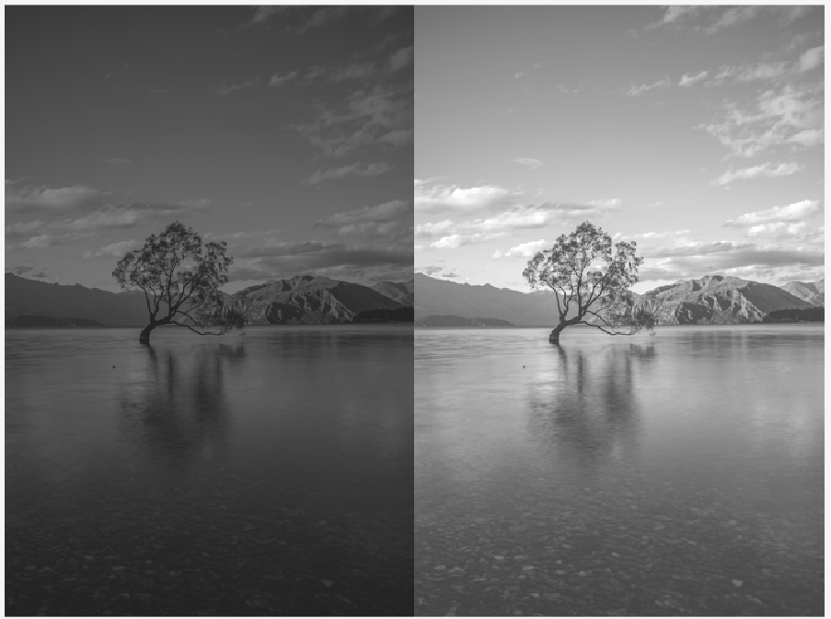

Used sobel filter in combination with with ‘edge’ function to find the edges of the circles in the image:

{original, filtered}  
  
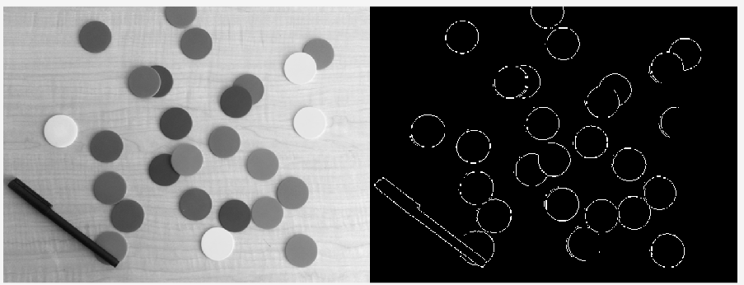

Loaded office image, improved contrast, then denoised, the sharpened:

{original, imadjust, imfilter, sharpen}

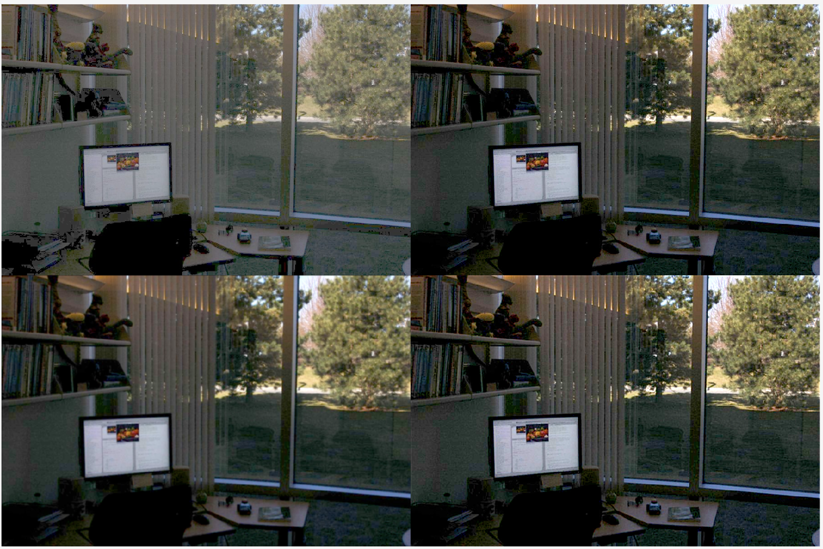

Difficult to fully denoise the image.

# Lab 4 – Morphological Image Processing

## Task 1 – Dilation and Erosion

Image dilation results:

Done, Dilate (star), Dilate (ones, Dilate (diagonal)

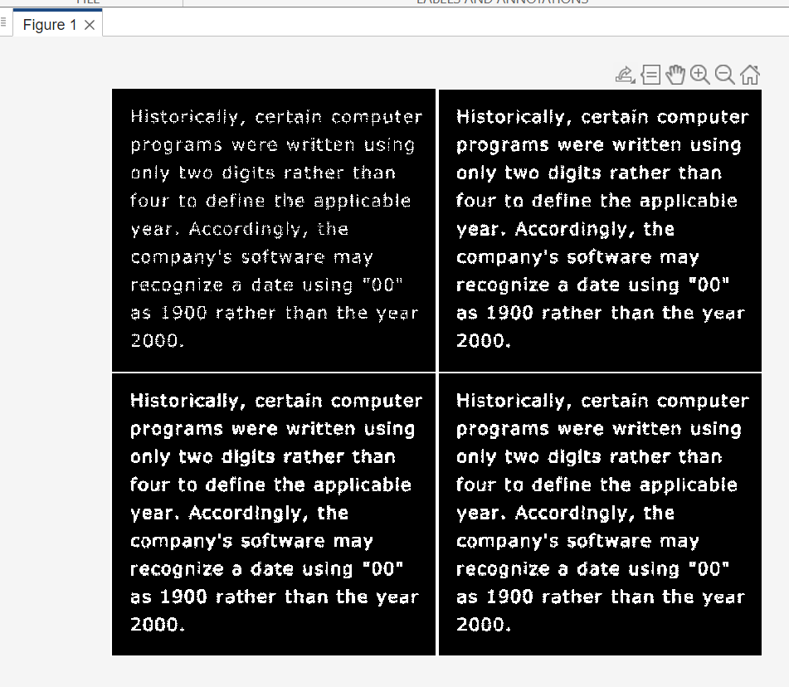

Double dilation (single star dilate, double star dilate):

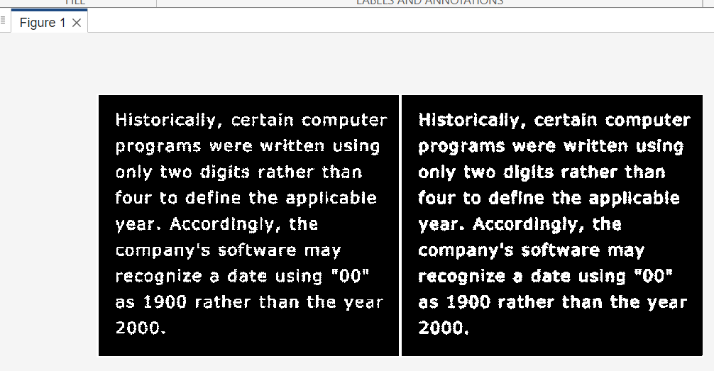

Image erosion results:

(Original, disk size 2, disk size 10, disk size 20)

The higher the erosion disk size, thinner the white shapes become, progressively ‘hiding’ the lines from the original image.

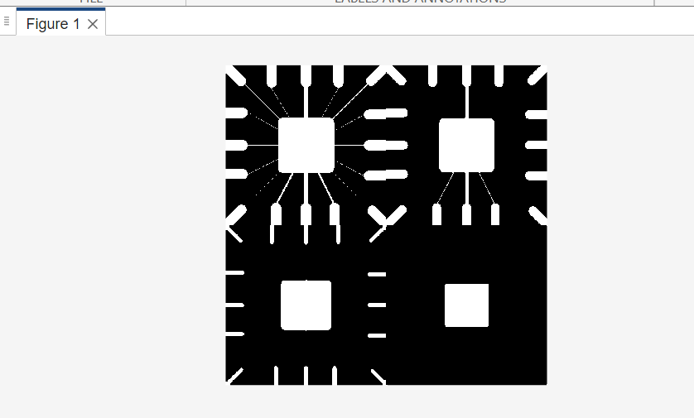

## Task 2 – Morphological Filtering with Open and Close

Image loaded, 3x3 structuring element created, image eroded, image dilated, image opened.

Montage {original, eroded, dilated, opened}

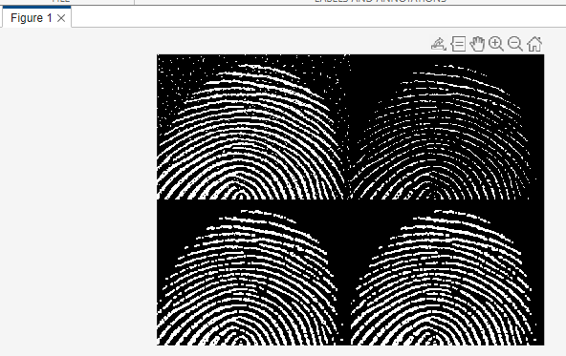

The resulting ‘opened’ image is clearer and has less noise that the original.

Increasing ‘strel square’ size from 3 to 5:

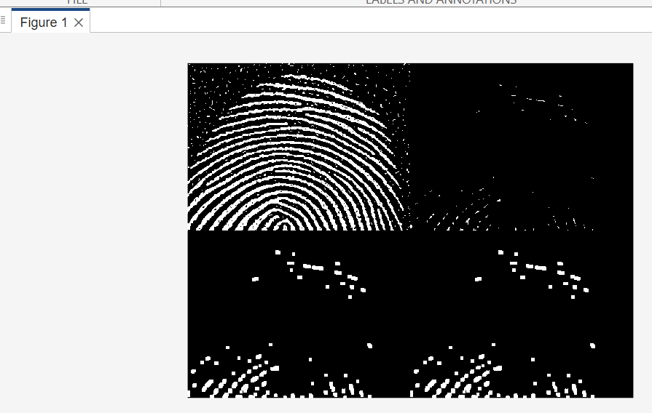

The image was eroded too far, loosing data. Result is poor.

Changing to ‘strel disk’ size 1:   
  
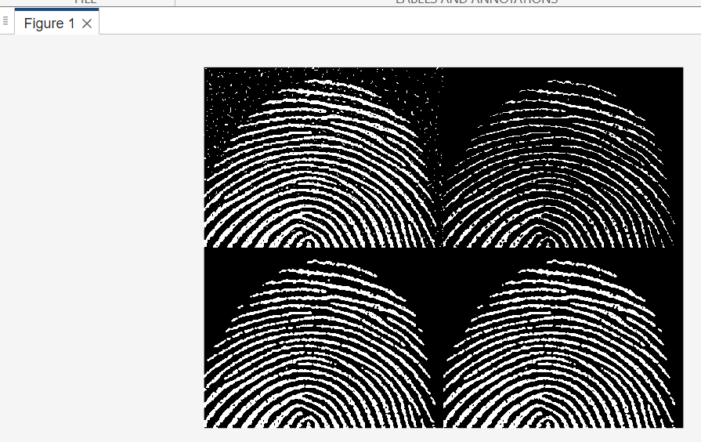

Shape size must be smaller than square size to achieve similar results.

Adding ‘imclose’ operation:

{opened, closed}  
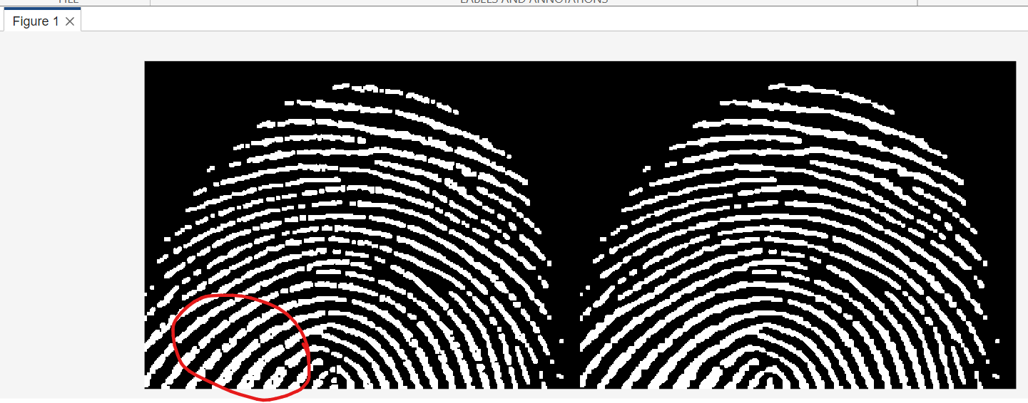

The dark parts within the white lines of the fingerprint are ‘filled in’. The result looks cleaner.

## Task 3 – Boundary detection

Converted image into binary image

{original, imcomplement, imbinarize}

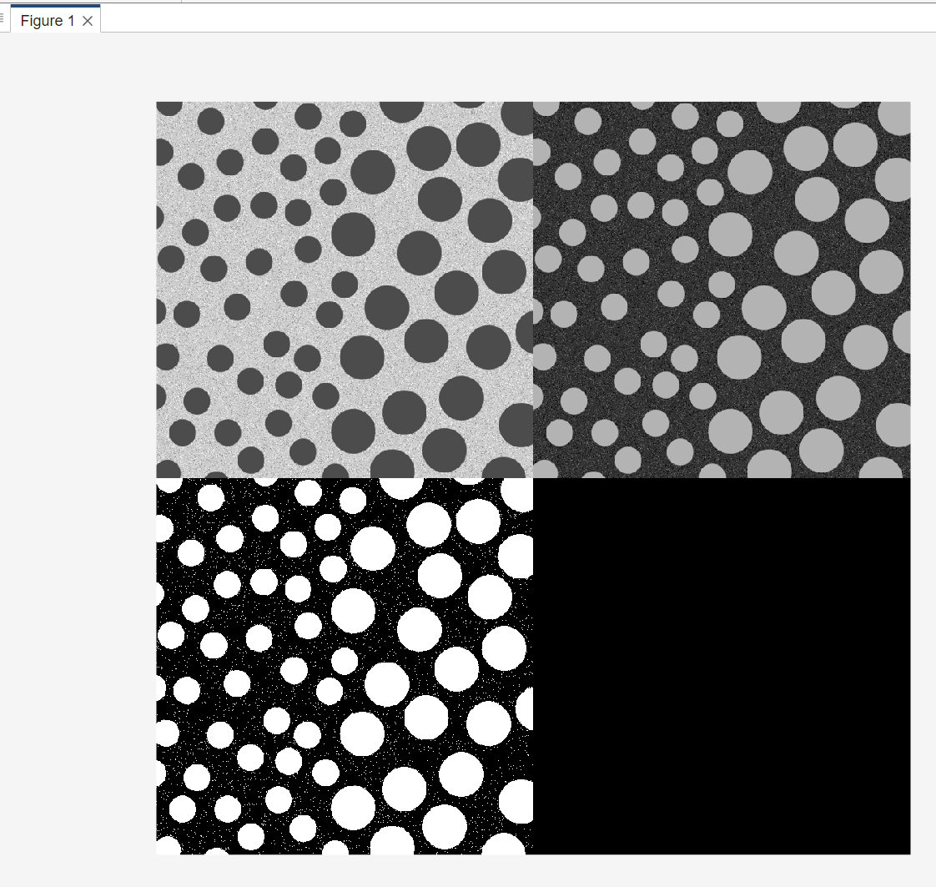

Eroded the binarized image, then subtracted from the original binarized image:

{imcomplement, imbinarize, imerode, imbiniraze – imerode}

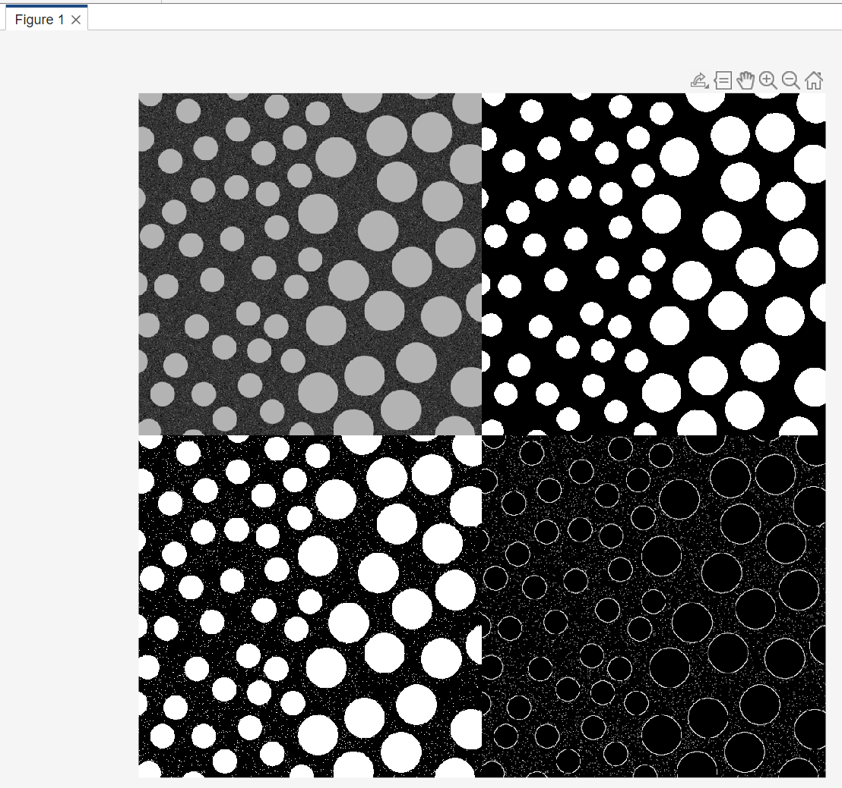

Improve result by adding a dilation step after erosion, then subtracting the eroded image from the dilated image. Result:

{without dilation step, with dilation step}  
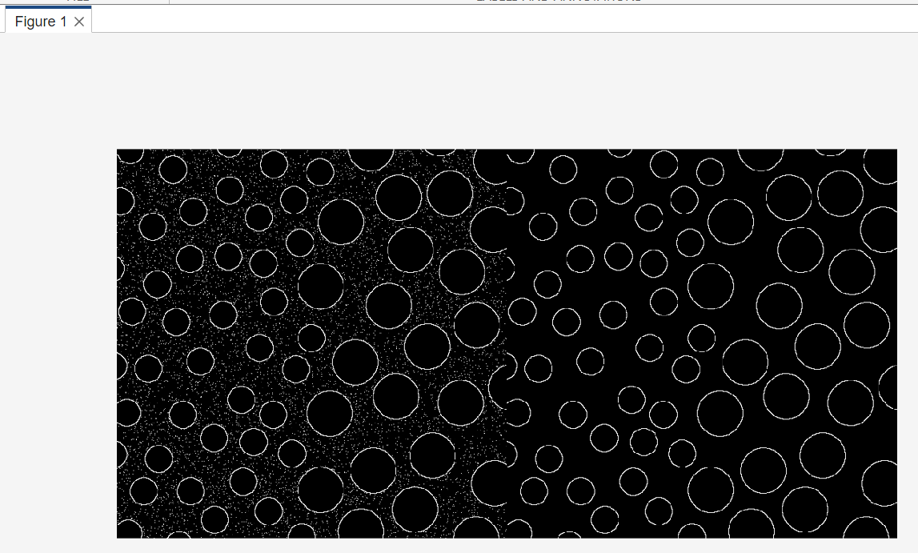

The result has removed all the noise from the original.

## Task 4 – Function bwmorph - thinning and thickening

Image converted to binary image:

{original, binarized}

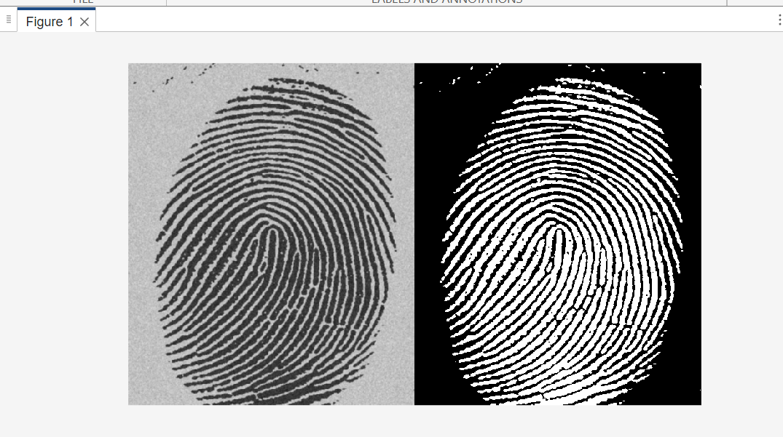

Thinning operation performed up to 5 times:

{original, 1x thin, 2x, thin, 3x thin, 4x thin, 5x thin}

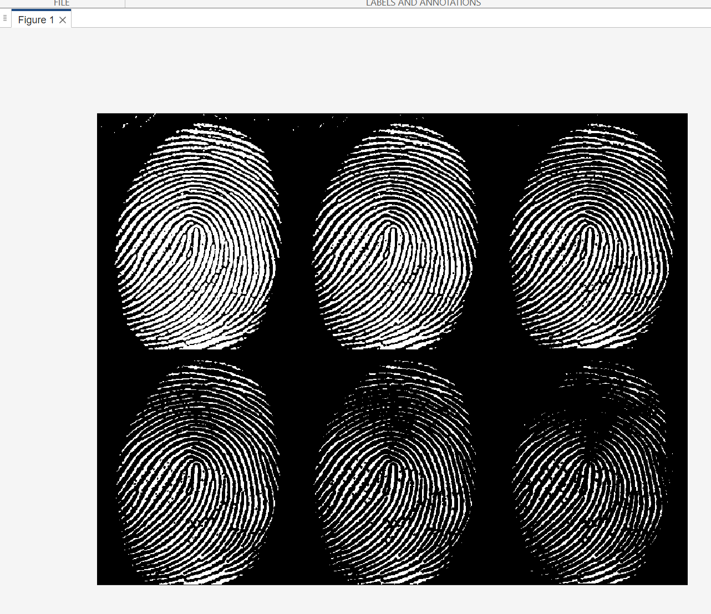

Thinning with infinite steps:

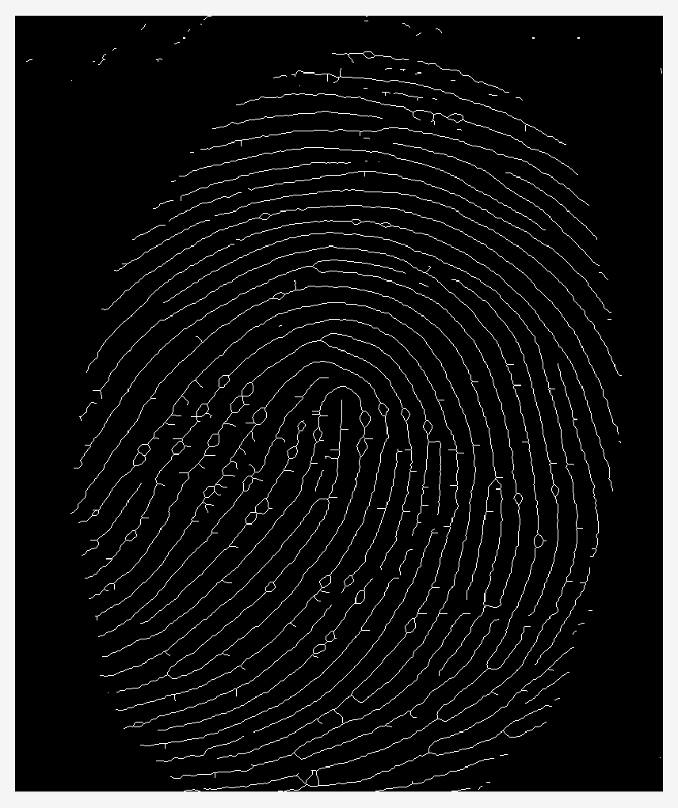

Changing colour of infinitely thinned image: 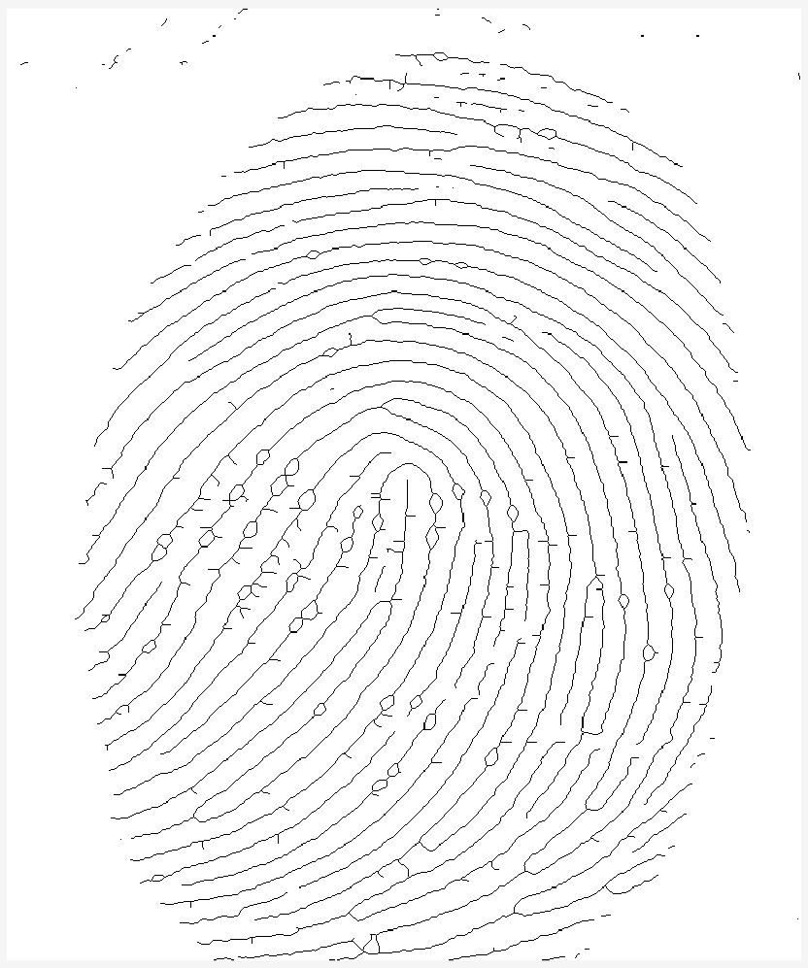

Thinning/thickening focuses on the white areas. For the thinned *white* coloured fingerprint on black background, the same result can be achieved by thickening the inverted image, i.e. by thickening the black fingerprint on the white background.

## Task 5 – Connected Components and labels

{original, *bwconncomp*}

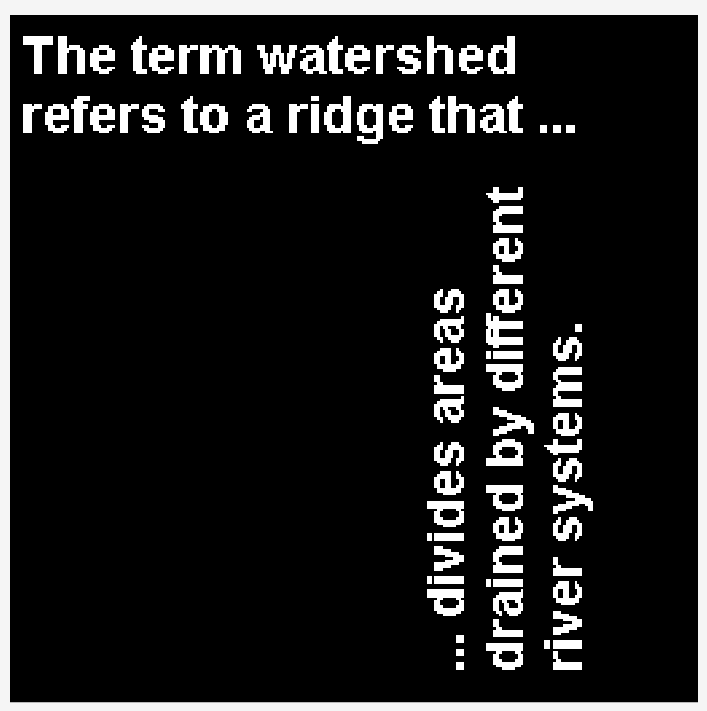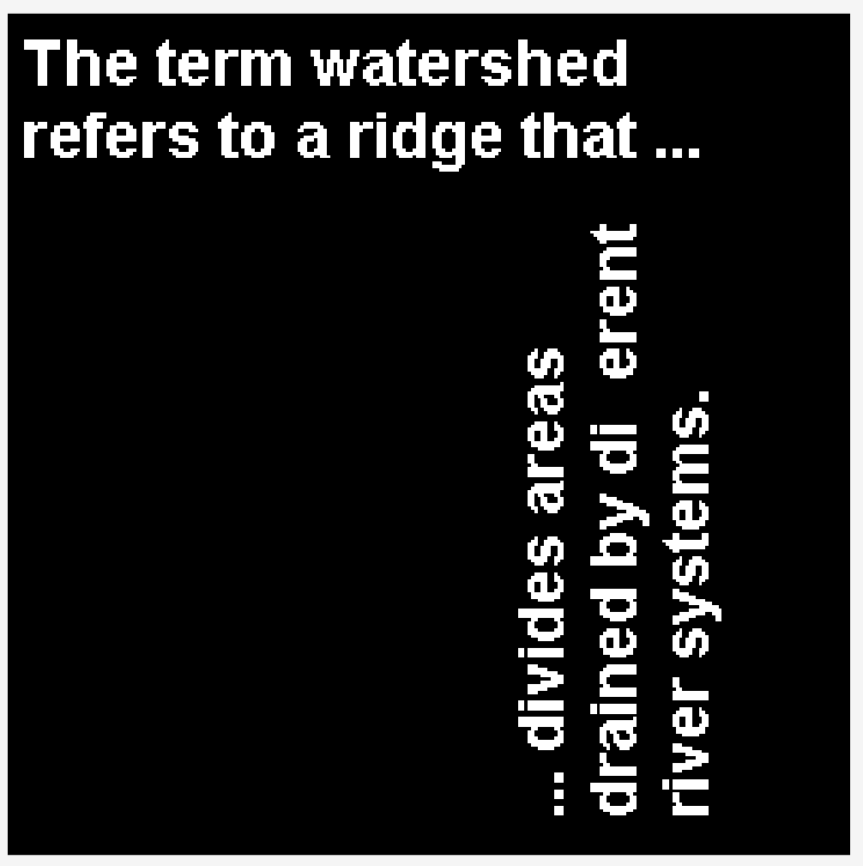

The ‘ff’ disappears after applying the *bwconncomp* function.

## Task 6 – Morphological Reconstruction

The script is results in the only the letters containing ‘straight lines’ being shown. First, the images is eroded using a tall matrix array, then the image is opened, and reconstructed to show only the desired letters.

{original, eroded, opened, recontstructed}

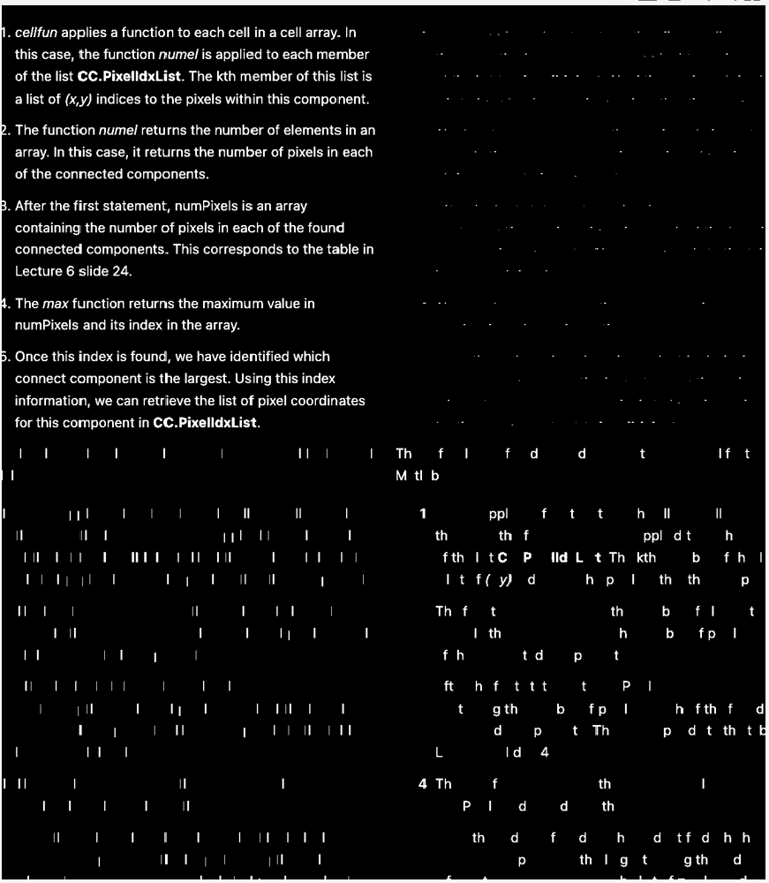

After using *imfill* function:

{original, imfill}

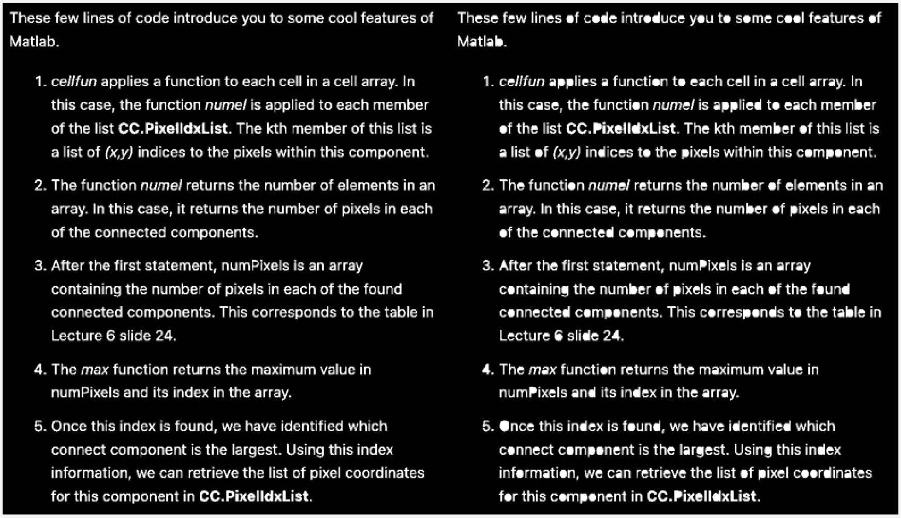

It seems that all the opening spaces inside the letters have been ‘filled in’.

## Task 7 – Morphological Operations on Grayscale images

{original, dilated, eroded, dilated – eroded}

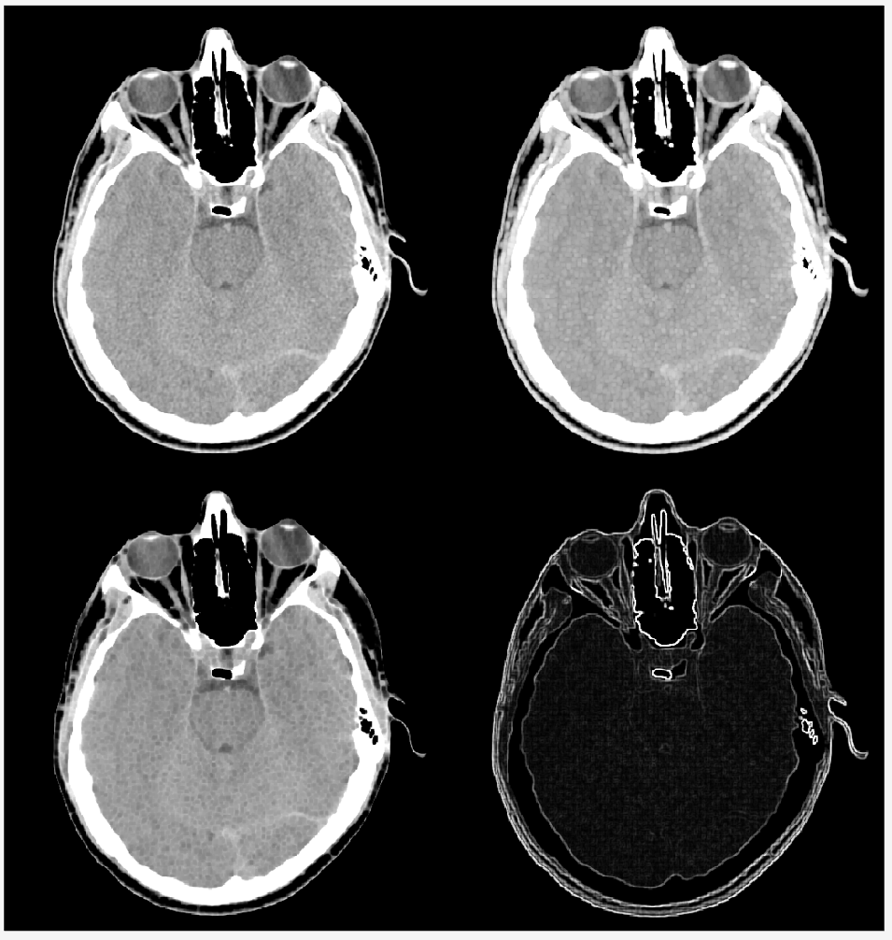

The final image shows the difference between the dilated and eroded images. Effectively showing the ‘contours of the original image.

## Challenge 1

Steps taken:

1. Imported the ‘fillings.tif’ image,
2. De-noised the image using ‘imfill’ function
3. Changed contrast of image using ‘imadjust’ function
4. Created a binary image using ‘imbinarize’

{original, imfill, imadjust, binarize}

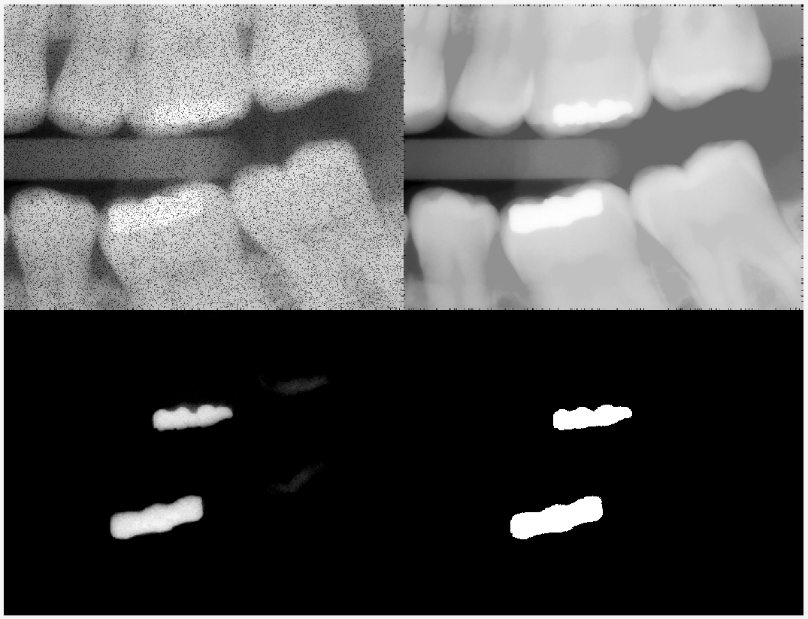

Subsequent steps taken:

1. Split image into 2 (top filling, bottom filling)
2. Then count non-zero pixels (i.e. the white pixels) using ‘count’ function

{top filling, bottom filling}



Result:

* Number of fillings identified = 2
* Pixel count top filling = 6777
* Pixel count bottom filling = 11308